Bell Ringer

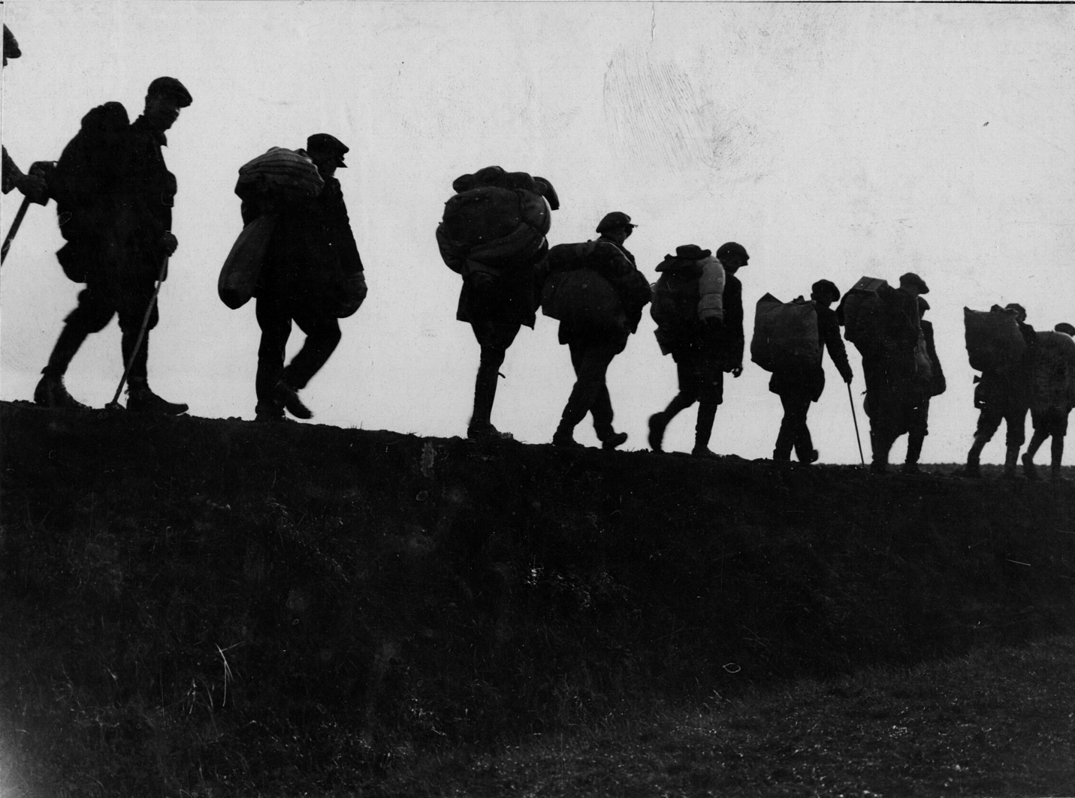

Image: https://catalog.archives.gov/id/16577081

Question: In your opinion, how does war change people? Explain your answer in at least three complete sentences.

Analyze and Wonder: Depictions of “The Other”

One of the most glaring examples of “othering” in American society happened during WWII.

Think about these questions as you analyze the cartoon below.
- What ethnic group is being negatively stereotyped here and what is the overall message?
- What historical events contributed to this false depiction?

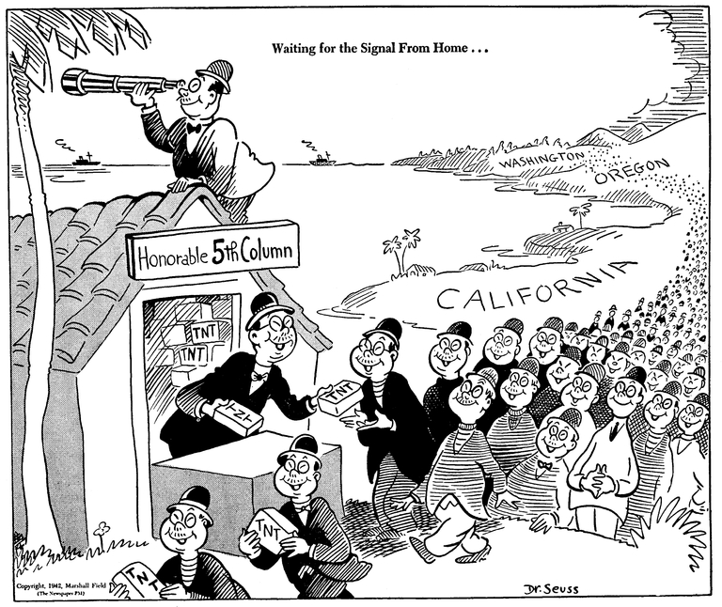

Image: http://library.ucsd.edu/speccoll/dswenttowar/index.html#ark:bb5222708w

Analyze and Wonder: Depictions of “The Other”

Believe it or not, this cartoon was sketched by Theodore Geisel, better known as Dr. Seuss. Here he stereotypically depicts Japanese-Americans as bomb-wielding agents who are waiting for Japan’s orders.

This cartoon is a direct reflection of how many Americans thought about their Japanese-American neighbors following the attack on Pearl harbor. These beliefs would ultimately influence the widespread internment of Japanese Americans by the government.

Image: http://library.ucsd.edu/speccoll/dswenttowar/index.html#ark:bb5222708w

Watch and Wonder: Revisiting Japanese-American Internment

Think about the questions below as we watch this video clip: http://bit.ly/2u9Od9W
- What event(s) dramatically changed the lives of Min and his family?
- What inspired Michael Williams to author a book about Japanese-American internment?
- What was “ironic” about Min’s call to serve in the military?
- Do you think the United States government did enough to make up for the internment of Japanese-Americans? If you don’t think so, what else would you have liked to seen done?

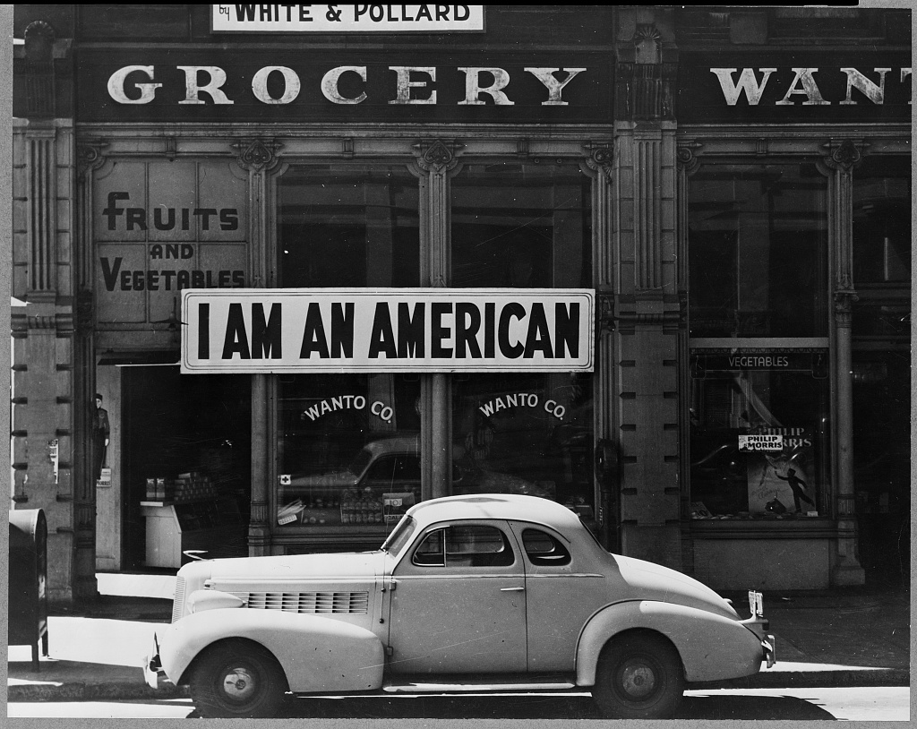

Image: http://hdl.loc.gov/loc.pnp/cph.3a24566

Contextualizing the Growth of Anti-German Sentiments in America

So why were there Anti-German feelings during WWI in America?

For the first two full years of WWI, the United States remained neutral as Europe was embroiled in conflict. However, certain events, developments, and long-term trends convinced many Americans that people of German heritage—both overseas and within the United States—were brutal, conniving, and unpatriotic.

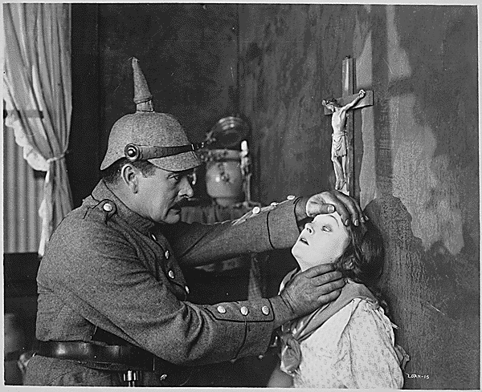

Image: https://catalog.archives.gov/id/516486

Key Event: The Sinking of the Lusitania.

On May 7, 1915, a German U-Boat sank the Lusitania, a passenger liner bound for New York City. Of the approximately 1,200 who died in the attack, 100 were Americans. Many Americans considered the torpedoing of the Lusitania a horrendous violation of war ethics.

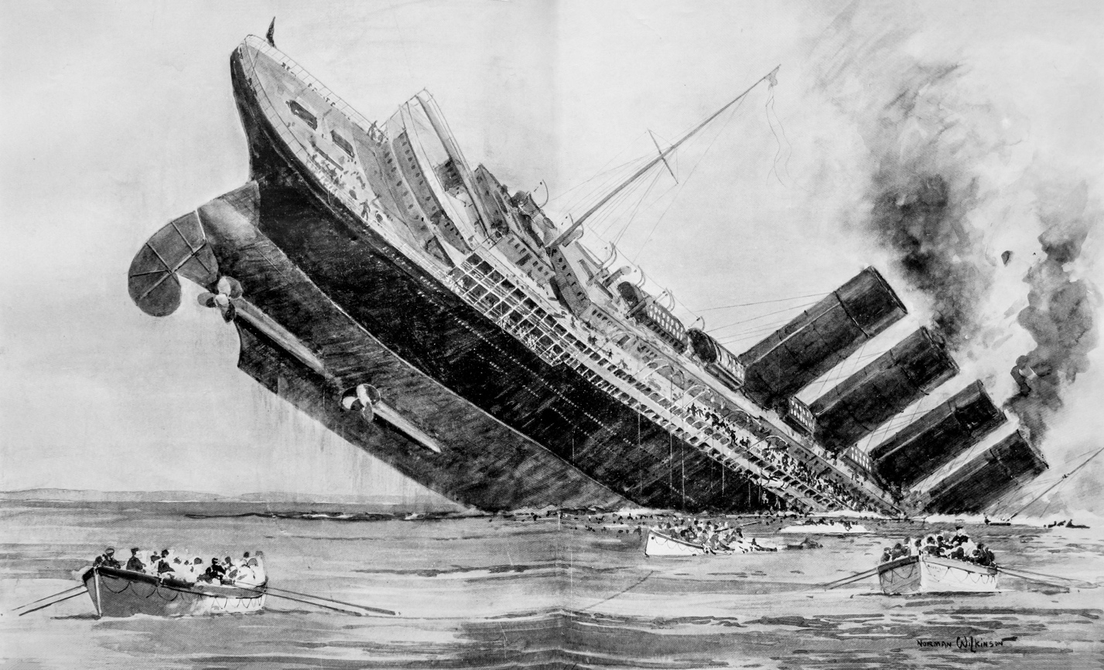

Image: https://commons.wikimedia.org/wiki/File:Sinking_of_the_Lusitania_London_Illus_News.jpg

Key Event: The Zimmerman Telegram.

In January 1917, the Germans sent a coded telegram intended for Mexican government officials. Captured and deciphered by the British government, the telegram stated that if Mexico were to engage in war against the United States, Germany could guarantee repossession of lands taken by America.

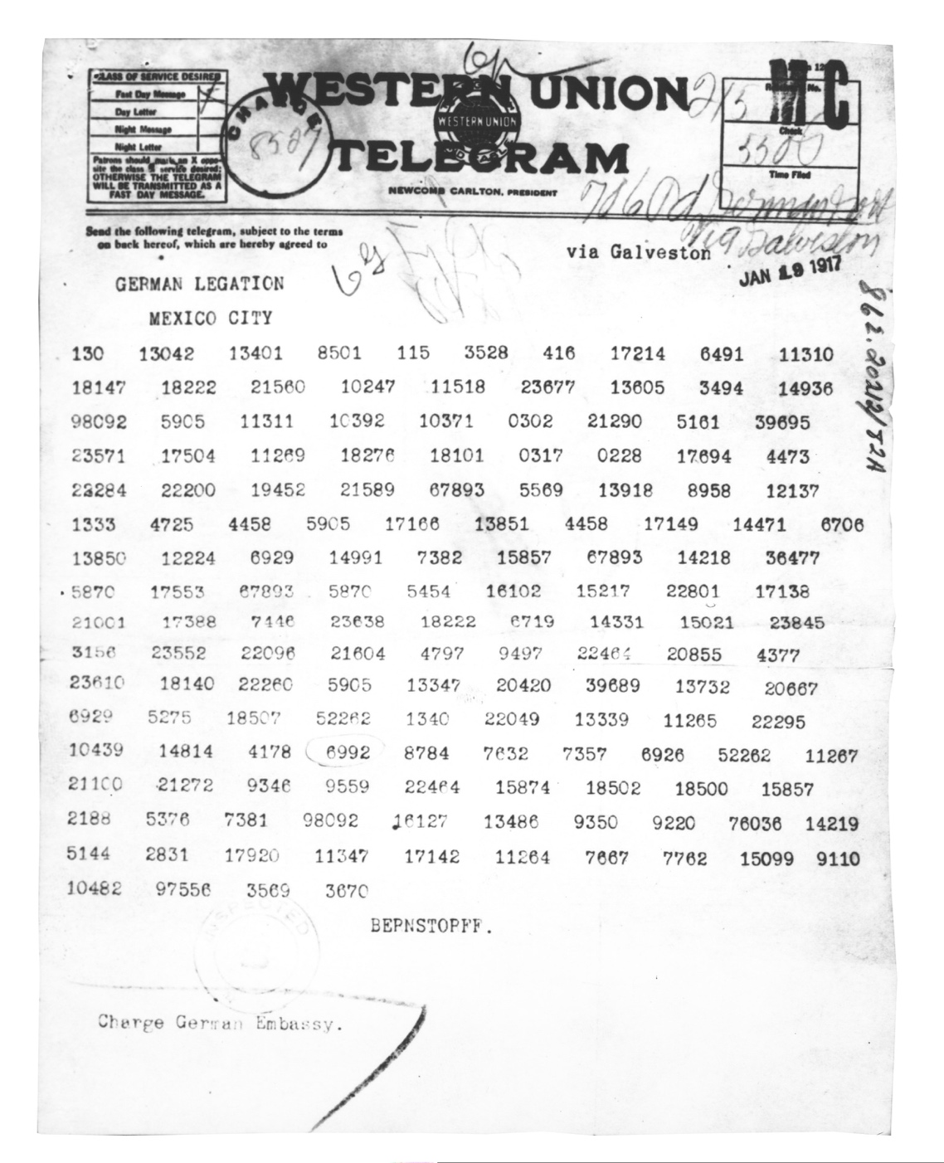

Image: https://catalog.archives.gov/id/302025

Key Issue: Alleged German War Crimes

Numerous investigations and newspaper reports asserted that Germany’s army had engaged in horrific acts of violence against innocent civilians during the war before America entered the conflict. While some of these allegations were somewhat true, others were exaggerated and used simply for propaganda purposes.

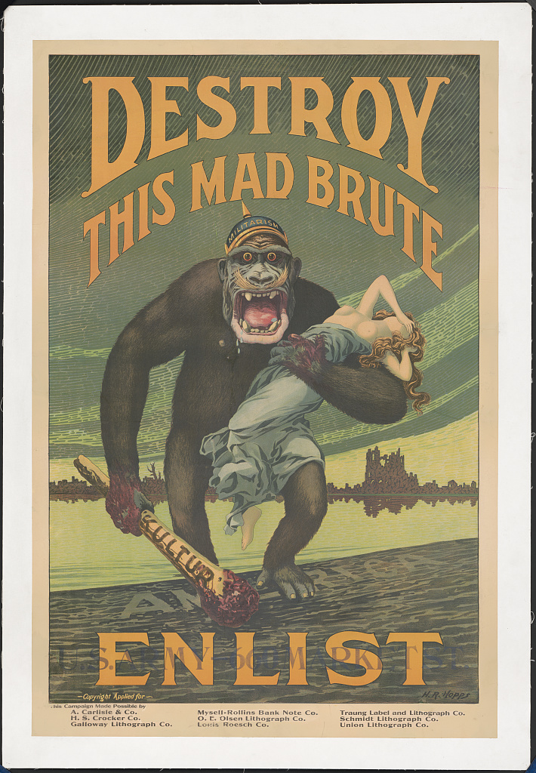

Image: http://hdl.loc.gov/loc.pnp/ds.03216

Key Issue: Wasteful German-American Breweries

Throughout WWI, many were pushing for the closing of breweries due to their vast use of grain that could be better utilized for feeding soldiers. Many American brewers happened to be of German descent and when they pushed back against these calls for closure, they were labeled as disloyal Americans. The efforts to close breweries was part of the larger plan of the growing Prohibition movement.

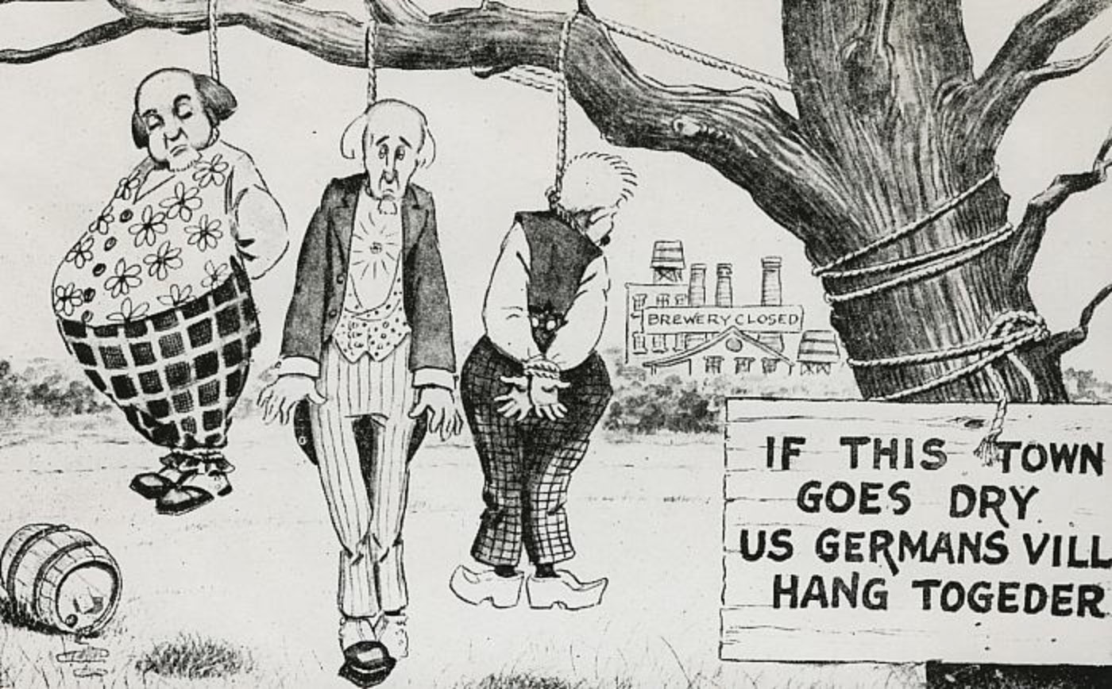

Image: http://www.historygrandrapids.org/photo/1518/prohibition-cartoon
Courtesy of the Grand Rapids Public Library Local History and Special Collections Department

Compelling Question: What was it like to be a German-American in Ohio during WWI?

Activity: Providing Deeper Context with Newspaper Analysis
Read the linked newspaper articles/advertisements and answer the questions in complete sentences.

Read article “German’s Toast Victory Amid Hochs in Cafes”
http://chroniclingamerica.loc.gov/lccn/sn83030214/1915-05-08/ed-1/seq-1/
- What were these German-Americans in New York City toasting and why were they toasting?
- Reportedly, how did some German-Americans justify the loss of life among the victims of this incident?
- How do you think this newspaper report would have affected feelings towards German-Americans in the United States?

Compelling Question: What was it like to be a German-American in Ohio during WWI?

Activity: Providing Deeper Context with Newspaper Analysis
Read the linked newspaper articles/advertisements and answer the questions in complete sentences.

Read article “Germany’s Plan to Embroil U.S. and Slice Off 3 States Angers”
http://chroniclingamerica.loc.gov/lccn/sn88084272/1917-03-01/ed-1/seq-1/
- Why do you think many of the public officials “declined to discuss” the Zimmerman Telegram with newspapers?
- How did Japanese officials respond to reports about the Zimmerman Telegram?
- Why do you think this particular newspaper was concerned with the contents of the Zimmerman Telegram?

Compelling Question: What was it like to be a German-American in Ohio during WWI?

Activity: Providing Deeper Context with Newspaper Analysis
Read the linked newspaper articles/advertisements and answer the questions in complete sentences.

Analyze advertisement “Welcome—Senator McAdoo!”
http://chroniclingamerica.loc.gov/lccn/sn84031081/1918-04-24/ed-1/seq-5/
- A quote from the so-called Bryce Report is utilized in this ad, stating “The man drove his bayonet with both hands, lifting the child into the air on his bayonet, he and His comrades still singing“. What was the Bryce Report? Do some online research!
- What is the overall message of this full-page advertisement?

Compelling Question: What was it like to be a German-American in Ohio during WWI?

Activity: Providing Deeper Context with Newspaper Analysis
Read the linked newspaper articles/advertisements and answer the questions in complete sentences.

Read article “A Dry Nation Coming!”
http://chroniclingamerica.loc.gov/lccn/sn84026820/1918-06-15/ed-1/seq-4/
- Why are the authors of this editorial against brewers in America?
- Do you think the authors of this editorial support President Wilson’s leadership? Select a piece of textual evidence from the editorial that demonstrates their views about President Wilson.
- Why do you think E.H. Leach used the Lusitania in his example of how much coal is wasted by brewers?

Activity: Your Answer to the Compelling Question

In complete sentences, give your best educated guess to this unit’s compelling question: What was it like to be a German-American in Ohio during WWI?

